Dis-Eur-Bulgaria-Neolithic-Idol

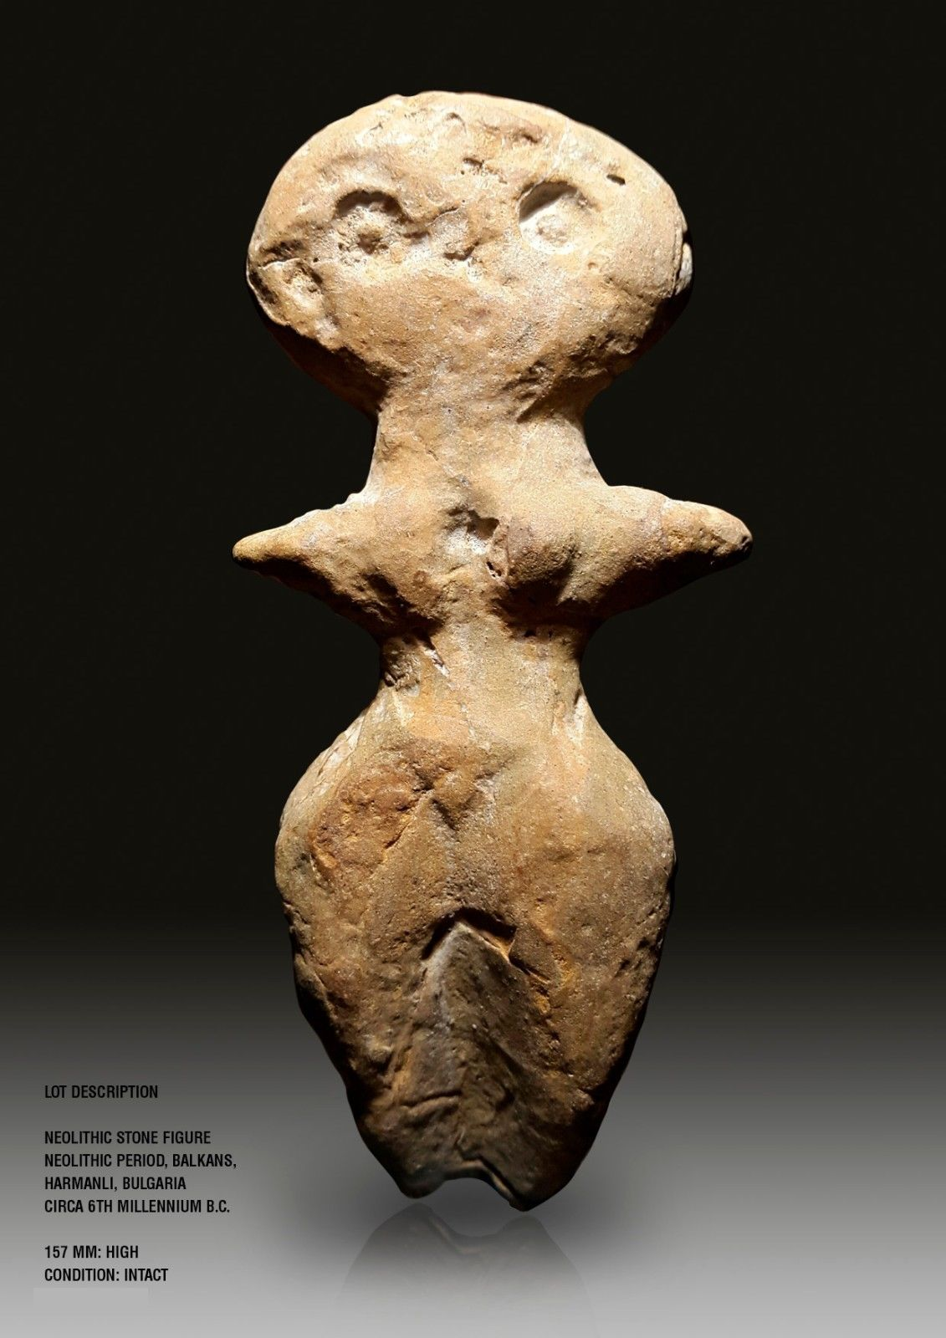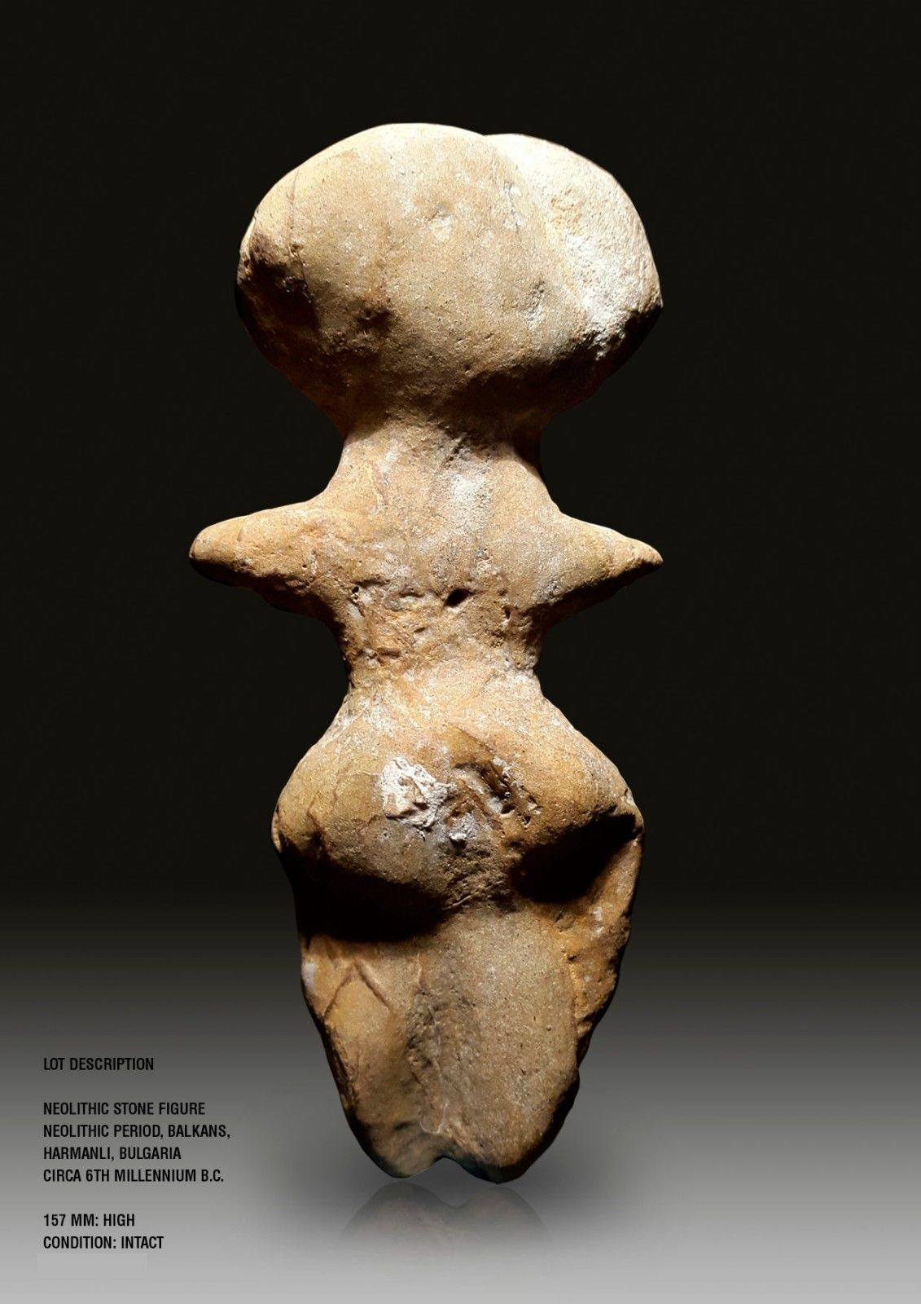

Formal Label: Bulgarian Neolithic Fired Clay Idol, 5th millennium BCE

Accession Number:

Date or Time Horizon: 5th millennium BCE

Geographical Area: Harmanli, Bulgaria

Cultural Affiliation: Neolithic

Media: Fired Clay

Dimensions: H 157mm

Weight:

Provenance: Italian Private Collection to 2007; then Martin Dimov

Mladost 2, 239/3/3/88, 1799 Sofia, Sofia, Bulgaria.

This fired clay, 6th millennium BCE, Neolithic mother goddess comes from the last period of the late Neolithic in Thrace (Karanovo IV period) above the flood-plain on the right bank of the Maritsa River, 3.5 km north of Harmanli in southeast Bulgaria. At this site most ceramic anthropomorphic and zoomorphic figurines have been purposefully fragmented or split apart and “desacralized” having fulfilled their ritual function, related to early farming fertility rituals (Băčvarov, Krum.2005). Therefore, this figurine is a particular rarity having remained intact.

The ceramic complex of the Hermanli Karanovo IV period is incised and white-encrusted decoration as well as dark-gray burnished ware with grayish white-painted decoration, which has its parallels in Turkish Thrace and northwest Anatolia. Some vessels have vertical handles with a cylindrical protome, which are found in Greek Thrace as well as at the nearby late Neolithic site near Lyubimets, also on the Maritsa river bank (Nikolov V., 2003).

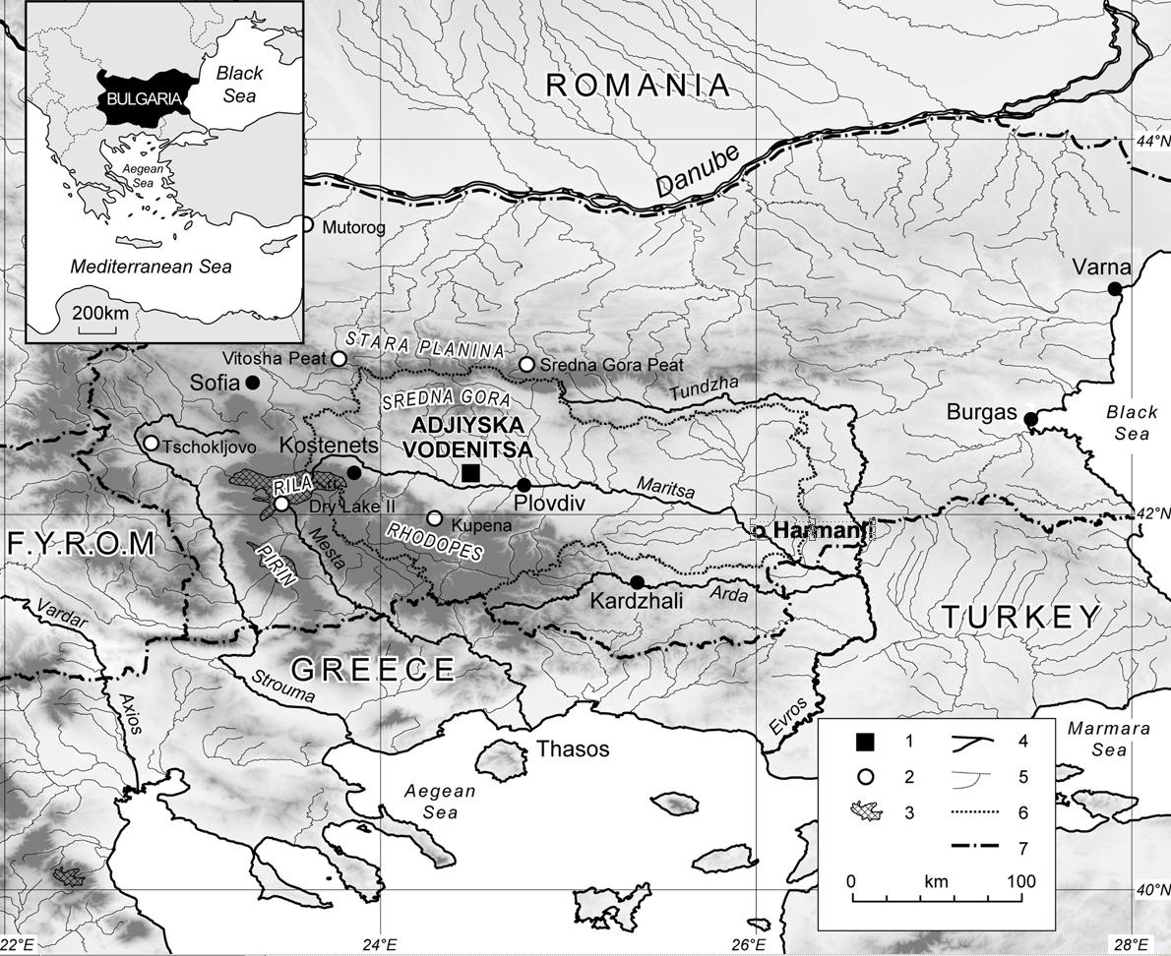

Fig. Locationof Harmanli in southeast Bulgaria. After https://geomorphologie.revues.org/docannexe/image/7747/img-1.jpg

The ruins of a late Neolithic site from the very end of sixth mill. BCE have been found on a lowly rising ground directly above the floodplain on the right bank of the Maritsa river, at about 3.5 kilometers to the north of the town of Harmanli, southeast Bulgaria. In the summer of 2004, a trench was made in the northeast periphery of the flat site, covering an area of 100 sq. m. The lack of features as houses, hearts/ovens etc., as well as the great number of pottery sherds in the cultural layer suggest that this was the most peripheral part of the prehistoric village, which center seems to had been localized – comparing it with other more or less simultaneous flat sites in the same area – on the ridge of the river terrace.

The depth of the cultural layer reached 60 to 70 cm. The finds belong to– Karanovo IV – and probably to its transitional phase to the early Chalcolithic, which was identified just recently. However, the upper layer has been almost totally destroyed by the continuing agricultural cultivation of the area, and only scattered pottery sherds have been found; more open shapes appeared in this phase, carinated vessels became more rounded, and the white-encrusted decoration disappeared. For the pottery of the lower layer, carinated and sharply profiled shapes are typical, and in those rare cases when the surface has not been eroded by the strongly alkaline chernozems, it is dark burnished. Most common feature of the ceramic complex of the Karanovo IV period at Harmanli is the incised and white-encrusted decoration as well as a specific dark-gray burnished ware with grayish white-painted decoration, which has its parallels in Turkish Thrace and northwest Anatolia. In spite of the limited area of the archaeological excavations, a total of over fifteen hundred flint pieces were found as well as artifacts of the types that are common for the Thracian late Neolithic. Plastic representations include anthropomorphs, zoomorphs, and other finds of clay and stone that are typical for the Karanovo IV material culture as a whole but have some specific features, too.

The surface of all clay figurines from Harmanli has been deeply eroded by the alkaline soil effects. Complete figurines have not been found; although fragmented, they are sufficiently instructive and detail the knowledge of the late Neolithic Karanovo IV anthropomorphs in Thrace. The Harmanli assemblage consists of six standing figurines, one sitting, one bended forward, and one anthropomorphic head.

Type 1 . I attribute two fragments to this very common Neolithic type - a left and a right half of standing female figurines (Fig. 1: 6, 8). Their fragmentation mode allows establishing with a relative certainty how these artifacts have been formed: two separate vertical halves have been modeled around two clay cylinders upon which the oversized buttocks have been sculptured. In the first case, a rounded belly has been formed but in the other, this part of the body has been damaged. In both cases, only the torso from the waist down to the upper end of the thighs is intact. The roughly smoothed surface is decorated with incised patterns.

With certain caution, I attribute one more standing figurine to the same type, only the right half of which has been preserved, with smooth undecorated brown surface (Fig. 1: 7).

The forming and fragmentation modes respectively of thеsе female clay figurines seem to give hints to their functioning in the early farmers’ ritual sphere as far back as the early Neolithic onwards. It is a fact that of the most anthropomorphs of this type either only halves are being found, or they are broken at least at two pieces; they come from the general context of the cultural layer or from pits – as is the case with one of the figurines from Harmanli (Fig. 1: 8) – the backfill of which is no more different than the cultural layer itself. As John Chapman’s analyses suppose, fragmentation have played a key role in the ritual system of the early farming societies (Chapman J., 2000).

Type 2 . This type consists of a solidly formed lower half of a standing female figurine (Fig. 1: 2). It is flat, has a trapezoid form, narrowing down of the protruded angular hips. Its sex has been emphasized with an oversized stomach upon (sic) which the vulva has been marked by a short vertical incision. The figurine is completely covered with thin white-encrusted incisions in the form of meandering patterns filled with white-encrusted dots, probably rendering a sort of garment.

Type 3 . A fragment of a flat torso with a short conical hand belongs to the group of the standing anthropomorphs (Fig. 1: 5). This figurine has not been decorated.

Type 4 . This rather peculiar type is represented by a female clay figurine with upper part, which has been strongly bended forward but now is missing (Fig. 1: 1). The figurine has been formed of one piece of clay. The lower part is solid; the legs have a rectangular cross-section and are bisected on the front by a vertical incision. The genital triangle has been marked with two oblique incisions. A late Neolithic anthropomorph with so lowly bended upper part was found at Tell Kapitan Dimitrievo, also in Thrace (Băčvarov K., 1999, tabl. 5/8), although it belongs to another iconographic type. However, the figurine from Harmanli has a specific peculiarity. Its surface is covered by a pointillée pattern, which consists of dots in groups of four, closely resembling the rosette patterned coat of a leopard. Its yellowish-brown color (with gray blots) is rather different than the surface of the other anthropomorphic figurines from Harmanli; most probably, it was intentionally sought, and emphasizes the overall “feline” impression. It should be kept in mind that the leopard (Panthera pardus) have never inhabited the Neolithic Balkans but the early farmers had not been unfamiliar with it, as is evidenced by certain feline figures (e.g. from the early Neolithic site at Eleshnitsa in the Mesta valley, southwest Bulgaria: Nikolov V., 1986). The “investment” of the character represented by the Harmanli figurine with a leopard skin seems to suggest her functions and meaning since in the early farmers’ religio-mythological beliefs, great cats have been closely related to the character of the female divinity. The bended position of her body also contributes to the general expression of the feminine principals.

Type 5 . The anthropomorph of this type belongs to the group of sitting figurines (Fig. 1: 4). Although only the right leg of the figurine is intact, it preserved enough telltale features to allow a comparative reconstruction using numerous parallels from Thrace with complete upper part, for instance from Tell Karanovo, Drama, Yasatepe-Plovdiv, Aşağıpınar, Lyubimets. These figurines have been formed of several parts: separately modeled legs, a cylindrical head and oval torso (see the reconstruction in Berger L., 2004, Figs. 5-6). In this case, the buttocks were formed separately and have probably been intended for sitting upon a stool, as distinguished from a figurine from Drama, which has been formed together with the stool (Fol A. et al., 1989, Taf. 35). By contrast with the well-smoothed or burnished surface of the figurines from the other sites, the surface of the Harmanli fragment is relatively rough but it is possible that this is due to the eroding effects of the alkaline soils. Besides its broad distributional area, this figurine type obviously showed a long stability since it had survived to the very end of the Thracian late Neolithic. The piece from Harmanli belongs to the Karanovo IV period, i.e. to the final of the Neolithic whereas the most figurines of the same type from other sites, including the nearby Lyubimets, predate it and belong to the Karanovo II-III to Karanovo III-IV periods.

Type 6 . A head with obvious anthropomorphic and ornithomorphic features (Fig. 1: 3). It has a flat crown and a telltale hooked nose/beak. This head has most likely belonged to a standing figurine.

Although the significance of the Neolithic bird figures is far from satisfactorily explained, it seems to be related to the female divinity, too, for instance, in her aspect of mistress of Death, though probably not as her symbols, as is per Mellaart (1964, 64), but as her attributes. It is possible to assume, too, a relation to the ancestors, as is per Nikolov, on the basis of examples from the very close – both culturally and territorially – late Neolithic site at Lyubimets (Nikolov V., 2002, 32; see also Băčvarov K., 2003, 152ff).

Bibliography

Băčvarov, Krum.2005. **Felines and bulls: Plastic representations from the late Neolithic site at Harmanli in the Maritsa valley,** ACTA TERRAE SEPTEMCASTRENSIS V. http://arheologie.ulbsibiu.ro/publicatii/ats/ats5/4plastic.htm

Băčvarov K., 1999 - Predmeti ot neolitnata materialna kultura. In: Nikolov V. (ed.) Selishtna mogila Kapitan Dimitrievo. Razkopki 1998-1999 . Sofia-Peshtera: Arheologicheski institut s muzey (1999), 55-76.

Băčvarov K., 2003 - Neolitni pogrebalni obredi: intramuralni grobove ot balgarskite zemi v konteksta na Yugoiztochna Evropa i Anatolia. Sofia: Bard (2003).

Berger L., 2004 - Anthropomorphe und zoomorphe Statuetten der Stufen Karanovo II-III bis III-IV aus dem Nordsüd-Schnitt am Tell Karanovo. In: V. Nikolov, K. Băčvarov, P. Kalchev (eds) Prehistoric Thrace. Proceedings of the International Symposium in Stara Zagora, 30.09 - 04.10.2003. Sofia - Stara Zagora: Institute of Archaeology with Museum (2004), 178-187.

Chapman J. C., 2000 - Fragmentation in Archaeology. People, places and broken objects in the prehistory of south-eastern Europe. London: Routledge (2000).

Fol A. et al., 1989 - Fol A., Katinčarov R., Lichardus J., Bertemes F., Iliev I. Bericht über die bulgarisch-deutschen Ausgrabungen in Drama (1983-1988). Neolithikum-Kupferzeit-Bronzezeit. In: Bericht der Römisch-Germanischen Kommission (70), 1989, 7-127.

Höglinger P., 1997 - Schmuck und Trachtbestandteile. In: Hiller S., Nikolov, V. (Hrsg.) Die Ausgrabungen im Südsektor 1984-1992. Salzburg-Sofia: Phoibos (1997), 271-283.

Ilcheva V., 2002 - Dve interesni nahodki ot kasnoneolitnoto selishte Hotnitsa-Orlovka, Velikotarnovsko. In: Godishnik na Arheologicheskija muzej Plovdiv , 9/1 ( 2002 ) , 68-73.

Kănčeva-Russeva T., 2000 - Ornamentirani keramichni predmeti ot praistoricheskoto selishte Hlebozavoda - Nova Zagora. In: Nikolov V. (ed.) Trakija i sasednite rajoni prez neolita I halkolita (Karanovski konferentsii za praistorijata na Balkanite, 1). Sofia: Arheologicheski institut s muzey (2000), 61-68.

`Nikolov V., 1986 - Vrazki na dolinata na r. Mesta s Anatolia prez rannija neolit. In: Arheologia (Sofia), (1986), 2, 5-10.

Nikolov V., 2003 - Anthropomorphe Plastik aus der spätneolithischen Siedlung Ljubimec, Südost-Bulgarien. In: Özdoğan M., Hauptmann H., Basgelen N. (eds.) From Village to Cities. Early Villages in the Near East. Istanbul: Arkeoloji ve Sanat Yayinlari (2003), 481-490.

Nikolov V., 2004 - Über dem Denotat der Kulttischen. In: Nikolov V., Băčvarov K. ( Hrsg. ) Von Domica bis Drama . Gedenkschrift für Jan Lichardus . Sofia: Archäologisches Institut mit Museum (2004), 33-41.

List of Figures

1. Late Neolithic site at Harmanli: 1-8 – anthropomorphic figurines.

\

|  |
| --- |
| Fig. 1. Late Neolithic site at Harmanli: 1-8 – anthropomorphic figurines |